|  |
| --- |
|  |
| Kitting |

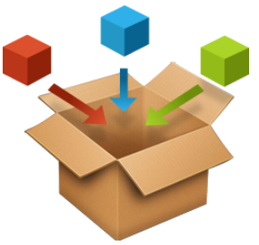

Project name:

KITTING for AX2012 R3 – Installation instruction

Prepared by:

Kurt Hatlevik

Contributors:

Table of Contents

1 Introduction 3

2 Prerequisites 3

3 Installation instructions 3

3.1 Installation procedure 4

3.2 Uninstallation procedure 4

**4** **Solution Footprint** 6

4.1 Tables 6

4.2 Extended datatypes and base enums 6

4.3 Macro 7

4.4 Classes 8

4.5 Forms 9

4.6 Menues 9

4.7 Other changed elements 10

4.8 Known best practice warnings 10

5 Translating the Kitting solution 11

6 Product suggestions and issues 12

7 Other solutions also available 12

Introduction

Kitting is a great alternative for companies that are not equipped with finished goods warehouse facilities or cannot afford the capital expenditure of setting up a finished goods warehousing facility.

# Prerequisites

Before installing KIT for Dynamics AX 2012 R3, please ensure that the system meets or exceeds the following Dynamics AX builds.

|  |  |
| --- | --- |
|  | Application build |
| DAX 2012 R3 | CU8/CU9 |

For other builds/versions a XPO-based build can be delivered, with a small charge of creating a delivery package.

# Installation instructions

The installation is packed in a single model, that can be imported.

|  |  |
| --- | --- |
| Model Name | Description |
| KIT | Contains the core Kitting solution. |

The name of this model is KIT_XX.axmodel, and contains all needed code and labels. The XX represent the version of the kitting solution. The installation instruction here is based on installing the Kitting solution in a development or test environment. For installation into a live environment, please follow [Microsoft instructions on how to install a ***model store***](http://technet.microsoft.com/EN-US/library/hh433530.aspx).

## Installation procedure

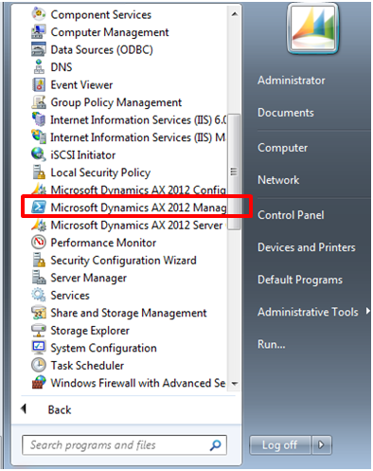Copy the KIT model into a temporary folder (like c:\KIT)

Install model  
Start Microsoft Dynamics AX Management Shell

Change directory to the temporary folder (c:\KIT)

Type in the command:

*axutil import /file:KIT_XX.axmodel*  
If you do get any conflicts, then you may use the overwrite parameter:

*axutil import /file:KIT_XX.axmodel /conflict:overwrite*

This will import the Kitting solution.

The next step is to restart all AOS’es, and then follow the upgrade wizard in Dynamics AX together with a **full synchronization** and a **full compile, and a full CIL-compile**. If the AXUtil.EXE parallel compile tool is used, then the following could be used. (Local paths must be used):

c:

cd\

cd C:\Program Files\Microsoft Dynamics AX\60\Server\MicrosoftDynamicsAX\bin

axbuild.exe xppcompileall /s=01 /altbin="C:\Program Files (x86)\Microsoft Dynamics AX\60\Client\Bin"

pause

There is no other setup parameters necessary to make the kitting solution work. Refer to the user guidelines to learn how to use the kitting solution.

There is also the option to install XPO files, and follow Microsoft guidelines: <http://msdn.microsoft.com/en-us/library/aa854197.aspx>

## Uninstallation procedure

To uninstall Kitting model do the following

* Start Microsoft Dynamics AX Management Console
* Type in the commands:
  + *axutil delete /model:KIT*

This will delete the Kitting model.

The next step is to restart all AOS’es, and to follow the upgrade wizard in Dynamics AX together with a full synchronization and a full compile.

Since the footprint of the Kitting solution is small, the effect of removing the kitting solution would just mean that the kitting lines will become ordinary sales lines. It is not expected that removing the kitting solution would have any major impact on transactions.

1. **Solution Footprint**

The kitting solution have a footprint, and do make some changes to standard AX tables and classes. Efforts have been made to minimize the footprint. The Kitting solution consists of the following objects. The Kitting solution have gone through rough quality checks to make sure it lives up to the expected standard of Dynamics AX.

## Tables

Kitting have changes to 9 standard AX tables, and 3 new tables to contain the relationship between the kitting header and kitting lines.

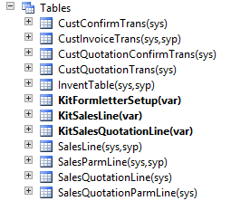

## Extended datatypes and base enums

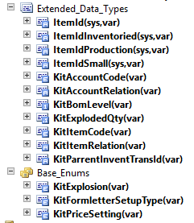

## Macro

The #KIT macro is a way to disable the kitting solution



By changing the KitEnabled from true to false, the kitting solution is disabled when you compile Dynamics AX.

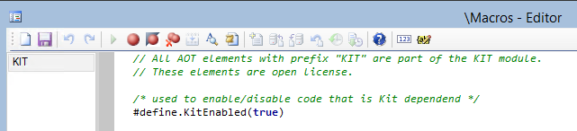

All kitting code have been maked with the "KIT" macro, and the following structure is used to switch on/off the kitting functionallity.

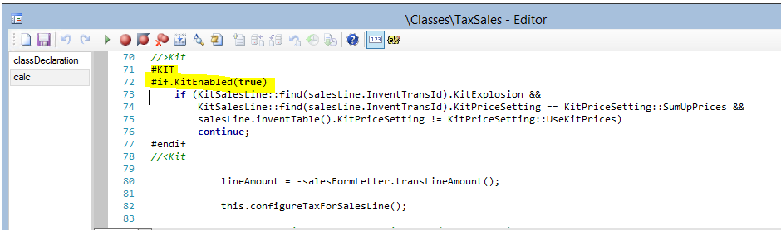

## Classes

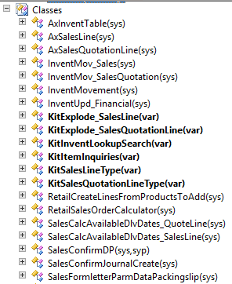 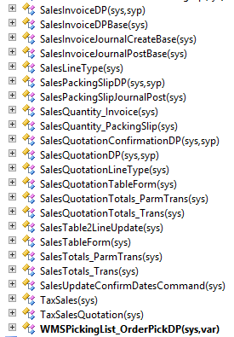

## Forms

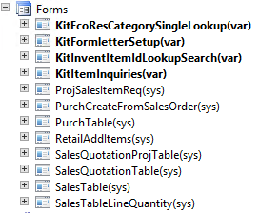

## Menues

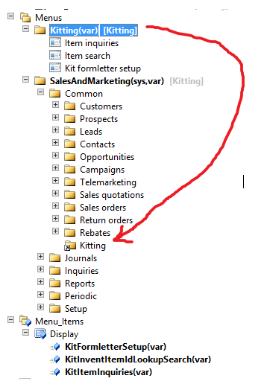

## Other changed elements

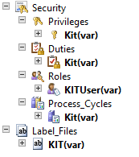

## Known best practice warnings

There are currently 14 known BP warnings. Theese will be fixed in the next release.

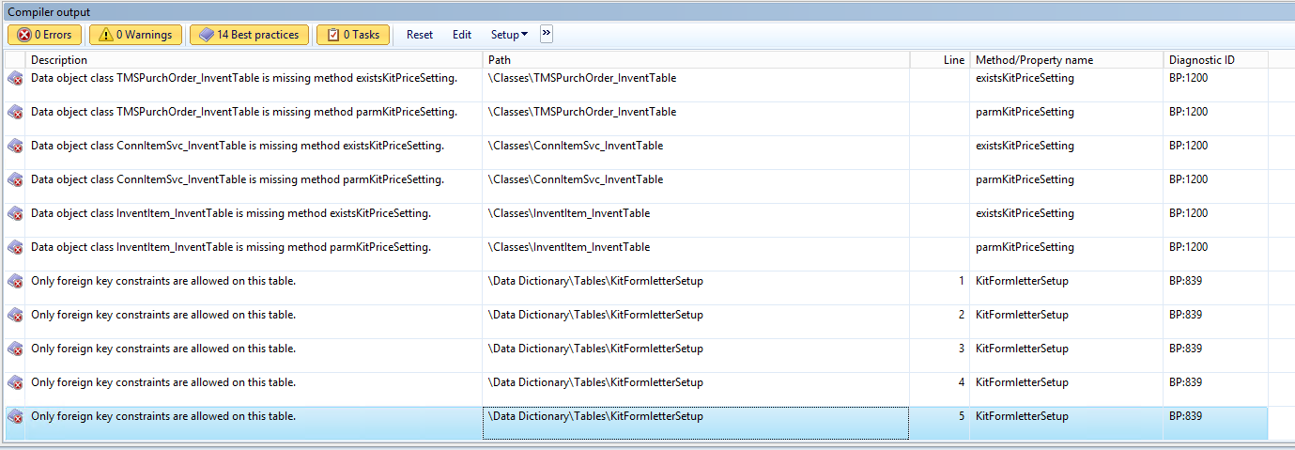

# Translating the Kitting solution

The Kitting solution only have EN-US labels. The Kitting solution have the following label that normally can be found at "C:\Program Files\Microsoft Dynamics AX\60\Server\MicrosoftDynamicsAX\bin\Application\Appl\Standard\AxKITen-us.ald"

@KIT30 Included in kit lot-id

@KIT31 Kit

@KIT32 Automatic explode on salesorder and transfer order

@KIT33 Kit bom level

@KIT34 Kit exploded quantity

@KIT35 Account code, that is Customer, group, or all

@KIT36 Customer Account or customer group

@KIT37 Kit sales line

@KIT38 Unit cannot be changed on a kit orderline.

@KIT39 Kitting items cannot have zero quantity.

@KIT40 Show kit lines

@KIT41 Hide kit lines

@KIT42 Show kits

@KIT43 Show the kit-lines in the sales order lines

@KIT44 Defines how kits should appear on the formletter.

@KIT45 Kit+lines

@KIT46 Kit only

@KIT47 Kitting form letter setup

@KIT48 Kitting items is blocked for this transaction.

@KIT49 Item inquiries

@KIT50 Disc 1%

@KIT51 Disc 2 %

@KIT52 Net price

@KIT53 Net price incl

@KIT54 Suppl.cost

@KIT55 Price/Qty units

@KIT56 Pcs Price

@KIT57 Misc ch.name

@KIT58 Misc ch.price

@KIT59 ABC1

@KIT60 ABC2

@KIT61 Kit formletter settup

@KIT62 Kitting

@KIT63 asdasd

@KIT64 Sold to customer

@KIT65 Item search

@KIT66 Number of results are %1 records,

@KIT67 Wildcard like '*' is not needed when setting parameters

@KIT68 Contains Kitting information

@KIT69 Setup of formletter in relation to kitting

@KIT70 Number of units exploded

@KIT71 Kit tasks and information

@KIT72 Kit. Only pick included items

@KIT73 Kit price setting

@KIT74 Should prices be summed up on the kit ?

@KIT75 Sum up prices

@KIT76 Use kit prices

@KIT77 Force update

@KIT78 Force update of a kit

@KIT79 Sum Up

@KIT80 % Margin

@KIT81 Markup %

@KIT82 Kit formletter setup

@KIT83 KIT user

@KIT84 Role that allows for working with kits

@KIT85 Explode kit again

Translating to a localized language must be performed in each project, and will not be maintained in the Codeplex site.

# Product suggestions and issues

Our mission is to provide our customers with the software, training, and support they need. Along with comprehensive training programs, we can also offer all customers a unique program to support solutions, sales and implementations.

The Kitting Codeplex Portal delivers role-tailored access to a wide range of tools and resources that include:

• A wide range of sales and marketing materials   
• Software Hotfixes   
• Pricelists   
• Training   
• User manuals, FAQ and whitepapers  
• Issues and product suggestions

The support/codeplex address is: <https://daxkitting.codeplex.com/>

# Other solutions also available

Other solutions are also available, and contact us for further details.

1. RF – Handheld and simplified processes in Dynamics AX

2. Label – Integration to Seagull BarTender for label printing and RFID

3. Retail import/export and Consignor integration

4. SYNC – Data syncronization between legal entities

5. Global Retail – Efficient tools for retailers for maintaining global products.